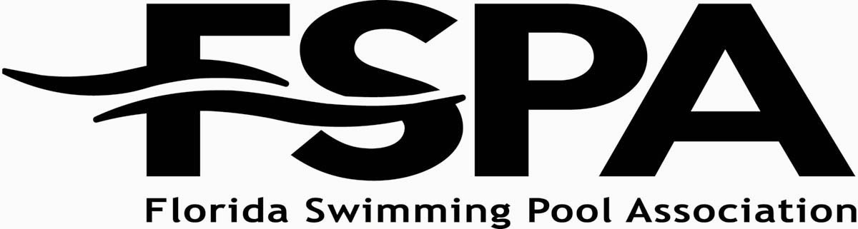

Board of Directors Meeting
June 8, 2019 Agenda
Margaritaville Resort Orlando

AGENDA
==============================================================================

      - Welcome & Call to Order
      - Pledge of Allegiance
      - Roll Call
      - President's Report
      - Approval of Minutes
        - Minutes of the Board of Directors meeting January 2019
      - Treasurer's Report
        - December Financials – final
        - April 2019 Financials
      - Committee Action Items
        - Government Relations
        - Builders’ Council
        - Service Council
        - Commercial Council
        - PIPAC
        - Education
        - Membership
        - Safety & Consumer Awareness
      - Executive Director’s Report
      - Old Business
      - Adjournment

