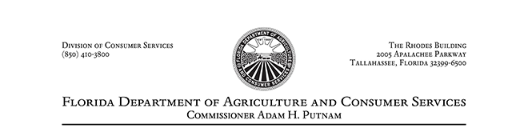

July 1, 2018

Dear Licensee,

The 2018 legislative season resulted in many positive changes to the LP Gas program in Chapter 527, Florida Statutes, that will be in effect as of July 1, 2018. These changes were aimed at modernizing the statute in addition to streamlining the registration process. The department is in the process of developing rules to implement these changes. We have received some feedback from licensees, that certain requirements are unclear pending the completion of the departments rulemaking. These concerns center mainly around the changes in licenses and requirements for Qualifiers and Master Qualifiers.

License categories have been consolidated from sixteen to six and the tiered fee structure for original versus renewal application fees has been removed. The new license categories along with the corresponding old license codes and the updated fees can be found on the enclosed information sheet.
Qualifiers for current Category II (dispenser) licenses will expire September 1, 2018, and must reapply for Qualifier status during the licensing process. Upon application and approval by the department, your Qualifier status will be updated and must be renewed every three years along with proof of 16 hours of approved continuing education.

Specialty Installer licenses will now be included in Category V (installers). Qualifiers for current Specialty Installers A-F will expire September 1, 2018, and must reapply for Qualifier status during the licensing process. Upon application and approval by the department, your Qualifier status will be updated and must be renewed every three years along with proof of 16 hours of approved continuing education.

The Master Qualifier requirements for current Category I (dealers) and Category V (installers) licenses remain unchanged. Changes to the statute for Master Qualifiers will only affect previously registered Specialty Installers. Previously, Master Qualifiers were not required for Specialty Installer licenses which have now been included in Category V (installers). Current Specialty Installer A-F licenses will be required to designate a Master Qualifier, with a minimum of three years' experience, during license renewal on September 1, 2018. The designated Master Qualifier must meet all the requirements of Section 527.0201, Florida Statutes, except for the demonstration of competency. The proof of experience as a qualifier will be used as a demonstration of competence for this transition. These Master Qualifiers will then be required to apply for renewal every three years and submit proof of 16 hours of approved continuing education.

I hope that this information helps to alleviate some of the confusion surrounding these upcoming changes. If you are unclear about the process regarding your specific license or licenses, please feel free to contact Mrs. Lori Joanos and her staff in the Bureau of Compliance at (850) 921-1600. We look forward to working with you to provide a smooth transition to our program updates.
For more information regarding these changes please click here.
Regards,
Liz Compton
Bureau Chief
Bureau of Compliance
