FSPA – NE CHAPTER IS HAVING
OKTOBERFEST 2017!!

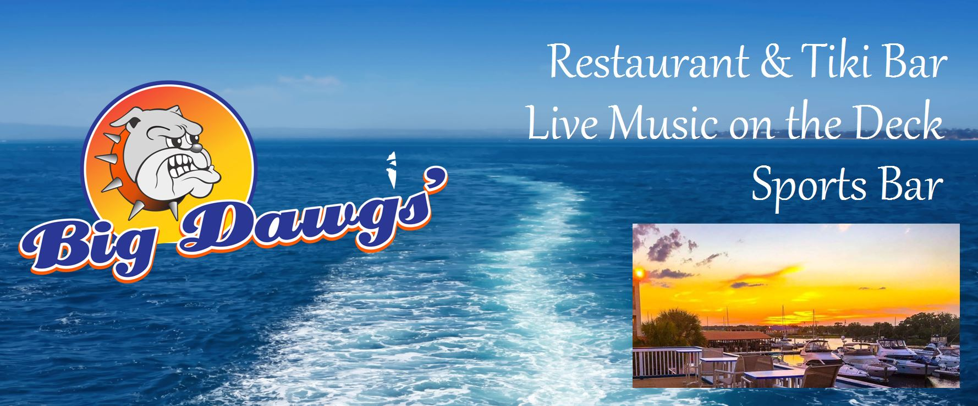

BIG DAWGS PIERSIDE
Friday October 6th at 6:00

2309 Beach Boulevard
(Under the bridge)
Jacksonville Beach 32250

6 p.m. – 9 p.m.

(Live Music by Down Pine and great food)
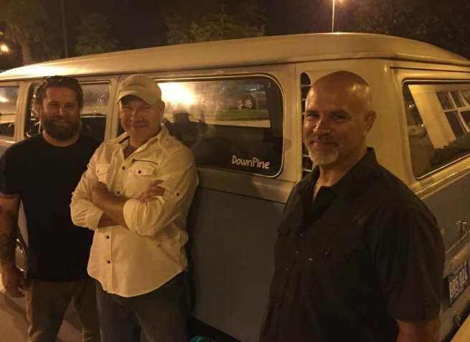
Cost: $25 per person!!
RSVP NO LATER THAN 9/22/17

Make this YOUR company party! Do not miss out on this fun filled event with friends, family and colleagues. This is not just a “pool person” event.

Enjoy TWO drink tickets per person for each RSVP including domestic beers, house wines and well liquor drinks. Enjoy a great food buffet and cash bar after your tickets!

Please complete & RSVP by 9/22!!

Name of Company: _____________________________________
Contact Person: _____________________Email:________________
Phone #: ______________________________________
# of People Attending ____________________

Send credit bill __________or mailing check _______

CREDIT CARDS OR CHECKS PRIOR TO EVENT ONLY. THERE WILL BE NO ONSITE PAYMENTS ACCEPTED.

Call/Fax/Email NOW to RSVP (no later than 9/22) - confirm your space to our premier event featuring:

Fun, food, music and friends!!

Call Debi Garner 904.743.2060 or Fax this form to: 904.745.6150
Email fspane@comcast.net

