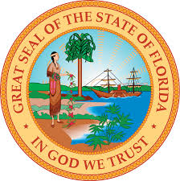

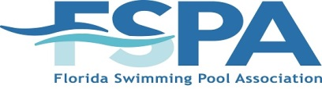

Broward Chapter Government Relations Program
Diving in the Deep End: Tuesday Aug 8th 2017

Location:
International Swimming Hall of Fame
One Hall of Fame Drive
Ft. Lauderdale, FL 33316
Program: 6:00 -8:00 p.m.
Light Hors d’oeuvres/ Dressy Casual/ No Shorts
Speakers: Jennifer Hatfield/Director of Government and Public Affairs
Wayne Bertsch/ Florida Legislative Consultant
For 30 years, issues critical to the swimming pool industry have been addressed by FSPA. In most cases, we have clearly been “reactionary” rather than pro-active. Recently, issues have arisen which threatened the ability of members to do their jobs and earn a living. WE CAN NO LONGER DEPEND ON OUR DEFENSIVE STYLE ALONE-WE NEED TO GO ON OFFENSE!
Please join us to be a part of making a difference in our political action Plan. Topics include:
- 2017 Session & Regulatory Report
- FSPA 489 Task Force
- PIPAC
- Building an active campaign to promote goodwill with legislators and collecting contributions to support our positions.
Join us for the meeting to make the BEST future for the pool industry in Florida

RESERVATION FORM
Business Name: ___________________ Contact Person: ________________________
Telephone: _________________ Email: __________________________
Attendees: 1. _______________________ 2. ______________________
3. _______________________ 4. ______________________
FSPA Broward Chapter
2555 Porter Lake Dr. Suite 106
Sarasota, FL 34240
Questions? Call: Michelle D’Aiuto Chapter Coordinator 1-800-548-6774 michelle@FloridaPoolPro.com

